Bethany Associate Reformed

Presbyterian Church

October 26, 2025

Rev. Benjamin Glaser, D.Min, Pastor

Lord’s Day Morning Worship Order of Service

Prelude
Welcome and Announcements
Call to Worship Daniel 2:20-23b
*Bible Song
*Invocation and Lord’s Prayer (Debts and Debtors)
*Scripture Lesson 2 Kings 6:1-7
Children’s Lesson
*Hymn
Pastoral Prayer
Anthem
Sermon “A Rest For the People” Hebrews 4:1-10
*Bible Song
*Benediction Matthew 24:42-44
*Doxology
*Postlude

Thank you for joining us today for the worship of Jesus Christ,
our Common Lord and Savior. If you would like to know
more about Bethany, please fill out one of the pew
cards and place them in an offering plate.

*- Please Stand If Able
Announcements

- There is a nursery provided upstairs (0-4) as need may arise.
- The November Bethany Banner is now available at the lecterns.
- The Blessing Box is in need of donations, especially supper-making products. Please place them on the table in the fellowship hall.
- Please place your offering in one of the four plates by the doors as you come in or as you go.

- 5th Sunday Psalm Sing will be on the 5th Sunday of November 30th.

PRAYER REQUESTS – Pam Walker, Tom Faulkner, John Currence, Beth Covington, Alfred Crawford, Portia Jones & Shut-Ins.

If you have any prayer requests, joys, concerns, or would like a visit, please let an Elder or Rev. Glaser know. His contact info is: 601-577-1359 and pastor.glaser@bethanyarp.org.

Nursery

October 26th:
November 2nd:

FINANCIAL REPORT
October 19th: $
Needed Weekly: $ 3,669.15
Fourth Quarter Mission Project: $125.00

Weekly Schedule of Classes & Studies
Sunday: Sabbath School – 10:00am
Morning Worship – 11:00am
Evening Worship – 5:30pm
Mon/Wed: Facebook Devotions and What’s That Word – 7:15am
Tues/Thurs: Prayer and Worship Help/Confessional Thursday Email
Wed. Night: Adult Study and Prayer Time/Youth Group - 6:30pm
Sermon Notes

Introduction

What is Paul’s Main Goal in Bringing Up Our Sabbath Rest?

How Does Faith Witness Itself in How We Rest in Christ?

Why Should We Be Careful to Observe the Sabbath Day?

How Does the Believer Find Rest in the Fourth Command?

Verses for Reflection

Exodus 16:23, Exodus 20:8-11, Isaiah 56:2-6, Isaiah 58:13-14,

Acts 13:14, Acts 17:2, Genesis 2:2-4, Matthew 11:28-30

Bethany Associate Reformed

Presbyterian Church

October 26, 2025

Rev. Benjamin Glaser, D.Min, Pastor

Lord’s Day Evening Worship Order of Service

Welcome

Call to Worship Psalm 119:137-144

Opening Prayer

Scripture Reading 1 Thessalonians 3

Song Selection #1 Bible Song of the Month #309

Season of Prayer

Song Selection #2 Pick a Bible Song/Hymn

Scripture Reading 2 Thessalonians 2:1-10

Teaching Time The End Times: The Antichrist

Closing Prayer

Benediction Isaiah 32:5-6

Sermon Notes

- What Does the Bible Teach About the Antichrist?

- Who is the Antichrist?
Welcome to Bethany ARP Church!
Founded in 1797 by Scots-Irish settlers seeking a place to worship our God according to the Scriptures, our vision is inspired by Jeremiah 6:16: “Stand in the ways and see, and ask for the old paths, where the good way is, and walk in it; then you will find rest for your souls.” Like the many old oaks in this area, we desire to grow deeply rooted in the nourishing waters of God’s Word, which flow from the ancient wells grounded in Jesus Christ.
We are a Reformed church, shaped by the biblical principles of the Protestant Reformation of the 16th century. Following in the footsteps of men like John Knox and Ebenezer Erskine, we hold to the Westminster Confession of Faith, which summarizes the essential teachings of Scripture.
We are also Presbyterian, meaning elders elected by the congregation govern our church. These elders work together within the broader Associate Reformed Presbyterian Church (ARP) to support our shared mission and ministry. Our motto, “In Thy Light We See Light,”, taken from Psalm 36:9 reflects our commitment to honoring Christ in preaching the gospel to all men and resting in His grace.

Join Us!
Whether you’re new to the area, exploring the Christian faith, or seeking a church home, we’d love for you to join us in worship and service. Rev. Glaser is always available.

BETHANY ARP CHURCH OFFICERS

SESSION
Jimmy McGill Ronnie Smith Adam Smith
Randy Carroll Fred Faulkner, Clerk of Session

ELDER EMERITUS
Jim Davidson

THE BOARD OF DEACONS

Class of 2025 Class of 2026 Class of 2027
Matthew Earls Joey McGill Caleb Robinson
Logan Carroll Matthew Carroll, Chairman
David McGill
Bethany
Associate Reformed
Presbyterian Church

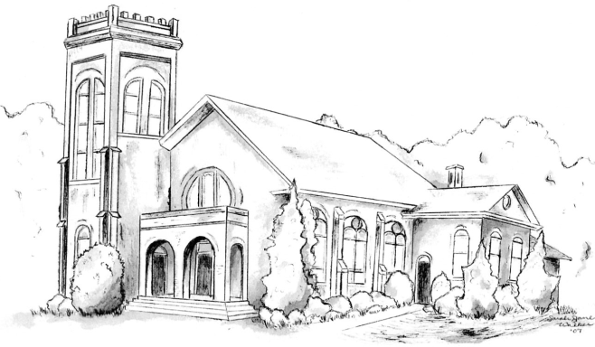

“I was glad when they said unto me,
Let us go into the house of the Lord.” – Psalm 121:1

Rev. Dr. Benjamin P. Glaser, Pastor

601-577-1359
www.bethanyarp.org
1454 Hwy 161N, Clover, SC 29710

OUR PURPOSE:

The purpose of Bethany ARP Church is to glorify God by:

Worshipping Him in Spirit and in Truth (John 4:24)
Equipping the Saints For the Work of Ministry (Eph. 4:12)
Reaching Our Community with Christ’s Gospel (I Pet. 2:9)

