Bethany Associate Reformed

Presbyterian Church

November 30, 2025

Rev. Benjamin Glaser, D.Min, Pastor

Lord’s Day Morning Worship Order of Service

Prelude
Welcome and Announcements
Call to Worship John 6:38-40
*Bible Song
*Invocation and Lord’s Prayer (Debts and Debtors)
*Scripture Lesson 2 Kings 8:1-6
Children’s Lesson
*Hymn
Pastoral Prayer
Anthem
Sermon “Deacons Must Be Reverent” 1 Timothy 3:8-13
*Bible Song
*Benediction Micah 4:1-2
*Doxology
*Postlude

Thank you for joining us today for the worship of Jesus Christ,
our Common Lord and Savior. If you would like to know
more about Bethany, please fill out one of the pew
cards and place them in an offering plate.

*- Please Stand If Able
Announcements

- There is a nursery provided upstairs (0-4) as need may arise.
- Thank you for all your gifts for the “pounding”! – Glaser Family.
- The Blessing Box is in need of donations, especially supper-making products. Please place them on the table in the fellowship hall.
- Annual Congregational meeting will be held on December 14th.
- Please place your offering in one of the four plates by the doors as you come in or as you go.
- 5th Sunday Psalm Sing will be tonight at 5pm. Bring a friend!

PRAYER REQUESTS – Pam Walker, Tom Faulkner, John Currence, Beth Covington, Crawford Family, Jones Family & Shut-Ins.

If you have any prayer requests, joys, concerns, or would like a visit, please let an Elder or Rev. Glaser know. His contact info is: 601-577-1359 and pastor.glaser@bethanyarp.org.

Nursery

November 30th:
December 7th:

FINANCIAL REPORT
November 23rd: $
Needed Weekly: $ 3,669.15
Fourth Quarter Mission Project: $125.00

Weekly Schedule of Classes & Studies
Sunday: Sabbath School – 10:00am
Morning Worship – 11:00am
Evening Worship – 5:30pm
Mon/Wed: Facebook Devotions and What’s That Word – 7:15am
Tues/Thurs: Prayer and Worship Help/Confessional Thursday Email
Wed. Night: Adult Study and Prayer Time/Youth Group - 6:30pm

Sermon Notes

Introduction

What is the Main Purpose of a Board of Deacons?

Where Do Deacons Come From in the Scriptures?

How is the Deacon Primarily to Shepherd God’s People?

What Kind of Expectations Should You Have For Deacons?

Verses for Reflection

1 Peter 1:15-16, Leviticus 11:44-45, Ephesians 1:4,

Ephesians 4:29, 2 Corinthians 7:1, Acts 6:1-7

Bethany Associate Reformed

Presbyterian Church

November 30, 2025

Rev. Benjamin Glaser, D.Min, Pastor

Lord’s Day Evening Worship Order of Service

Prelude

Greetings and Announcements

*Call to Worship Rev. Benjamin Glaser

*Opening Prayer

Word of Purpose in Singing God’s Word

Opening Bible Song Set List*

Season of Favorites

Closing Bible Song Christian Unity #280

Benediction and Closing Prayer Rev. Mark Miller

*Bible Song Set List

- Precepts For Childhood #72
- Prayer For Pardon #107
- He Set Me Free #133
- The Church’s Doxology #155
- Harden Not Your Heart #222
- Happiness and Holiness #249
- God Shall Guard #263
- Jesus Our Only Hope #295
- The Excellency of God #303
- Let Them Praise His Name #26(itb)

Welcome to Bethany ARP Church!
Founded in 1797 by Scots-Irish settlers seeking a place to worship our God according to the Scriptures, our vision is inspired by Jeremiah 6:16: “Stand in the ways and see, and ask for the old paths, where the good way is, and walk in it; then you will find rest for your souls.” Like the many old oaks in this area, we desire to grow deeply rooted in the nourishing waters of God’s Word, which flow from the ancient wells grounded in Jesus Christ.
We are a Reformed church, shaped by the biblical principles of the Protestant Reformation of the 16th century. Following in the footsteps of men like John Knox and Ebenezer Erskine, we hold to the Westminster Confession of Faith, which summarizes the essential teachings of Scripture.
We are also Presbyterian, meaning elders elected by the congregation govern our church. These elders work together within the broader Associate Reformed Presbyterian Church (ARP) to support our shared mission and ministry. Our motto, “In Thy Light We See Light,”, taken from Psalm 36:9 reflects our commitment to honoring Christ in preaching the gospel to all men and resting in His grace.

Join Us!
Whether you’re new to the area, exploring the Christian faith, or seeking a church home, we’d love for you to join us in worship and service. Rev. Glaser is always available.

BETHANY ARP CHURCH OFFICERS

SESSION
Jimmy McGill Ronnie Smith Adam Smith
Randy Carroll Fred Faulkner, Clerk of Session

ELDER EMERITUS
Jim Davidson

THE BOARD OF DEACONS

Class of 2025 Class of 2026 Class of 2027
Matthew Earls Joey McGill Caleb Robinson
Logan Carroll Matthew Carroll, Chairman
David McGill
Bethany
Associate Reformed
Presbyterian Church

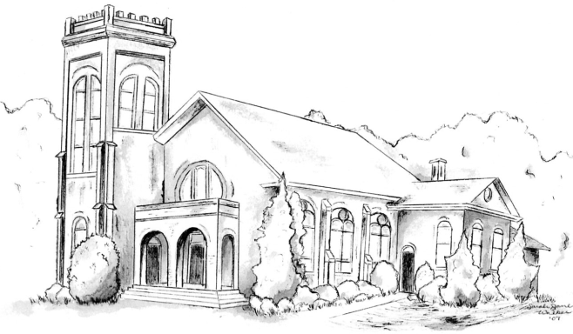

“I was glad when they said unto me,
Let us go into the house of the Lord.” – Psalm 121:1

Rev. Dr. Benjamin P. Glaser, Pastor

601-577-1359
www.bethanyarp.org
1454 Hwy 161N, Clover, SC 29710

OUR PURPOSE:

The purpose of Bethany ARP Church is to glorify God by:

Worshipping Him in Spirit and in Truth (John 4:24)
Equipping the Saints For the Work of Ministry (Eph. 4:12)
Reaching Our Community with Christ’s Gospel (I Pet. 2:9)

