Bethany Associate Reformed

Presbyterian Church

May 24, 2026

Rev. Benjamin Glaser, D.Min, Pastor

Lord’s Day Morning Worship Order of Service

Prelude
Welcome and Announcements
Call to Worship John 5:10-11
*Bible Song
*Invocation and Lord’s Prayer (Debts and Debtors)
*Scripture Lesson 2 Kings 16:10-16
Children’s Moment
*Hymn
Pastoral Prayer
Anthem
Sermon “Vengeance is Mine” Romans 12:19-20
*Bible Song
*Benediction Lamentations 3:22-26
*Doxology
*Postlude

Thank you for joining us today for the worship of Jesus Christ,
our Common Lord and Savior. If you would like to know
more about Bethany, please fill out one of the pew
cards and place them in an offering plate.

*- Please Stand If Able

Announcements

- There is a nursery provided upstairs (0-4) as need may arise.
- Thank you to everyone who came out to our Table Talk event. We had a great time! Please see the car wash insert for today.
- The Blessing Box is in need of donations, especially supper-making products. Please place them on the table in the fellowship hall.
- Please begin to be in prayer for the 2026 ARP General Synod.
- If you are not seeing emails from the Church Social app, please see Kelly Gordon. We either have the wrong email, or we do not have an email for you at all. She will help you get set up!
- We will be having a Psalm Sing on May 31st at 5pm. Bring a friend!
- Please place your offering in one of the four plates by the doors as you come in or as you go.

PRAYER REQUESTS – Eddie and Ruthann Helms, Thiessen and Perry family, Mary Clay Crawford, High School Seniors, & Shut-Ins.

If you have any prayer requests, joys, concerns, or would like a visit, please let an Elder or Rev. Glaser know. His contact info is: 601-577-1359 and pastor.glaser@bethanyarp.org.

Nursery

May 24th:
May 31st:

FINANCIAL REPORT
May 17th : $
Needed Weekly: $ 3,669.15
First Quarter Mission Project: $0.00

Weekly Schedule of Classes & Studies
Sunday: Sabbath School – 10:00am
Morning Worship – 11:00am
Evening Worship – 5:30pm
Mon/Wed: Facebook Devotions and What’s That Word – 7:15am
Tues/Thurs: Prayer and Worship Help/Confessional Thursday Email
Wed. Night: Adult Study and Prayer Time/Youth Group - 6:30pm
Sermon Notes

Introduction

What is the Main Point Paul is Seeking to Address Here?

Why Must Vengeance Remain the Domain of God?

How Do We Unjustly Seek the Destruction of Other People?

What is the Danger of Avenging Ourselves With Our Enemies?

Verses for Reflection

Deuteronomy 32:35, Nahum 1:2, 2 Thess. 1:6-8

Hebrews 10:30-31, Rev. 6:9-10, Psalm 94:1-2

Bethany Associate Reformed

Presbyterian Church

May 24, 2026

Rev. Benjamin Glaser, D.Min, Pastor

Lord’s Day Evening Worship/Grad Service Order of Service

Welcome

Call to Worship Psalm 137:1-9

Opening Prayer

Scripture Reading Hebrews 3

Song Selection #1 Bible Song of the Month #15

Season of Prayer

Song Selection #2 Pick a Bible Song/Hymn

Scripture Reading Galatians 3:23-26

Teaching Time How to Read the Bible: OT Laws and the NT

Closing Prayer

Benediction Job 23:10-12

Sermon Notes

- How Are the Old Testament Rules to Affect Us Today?

- What is a Danger of Thinking Only NT Informs Ethics?
Welcome to Bethany ARP Church!
Founded in 1797 by Scots-Irish settlers seeking a place to worship our God according to the Scriptures, our vision is inspired by Jeremiah 6:16: “Stand in the ways and see, and ask for the old paths, where the good way is, and walk in it; then you will find rest for your souls.” Like the many old oaks in this area, we desire to grow deeply rooted in the nourishing waters of God’s Word, which flow from the ancient wells grounded in Jesus Christ.
We are a Reformed church, shaped by the biblical principles of the Protestant Reformation of the 16th century. Following in the footsteps of men like John Knox and Ralph Erskine, we hold to the Westminster Confession of Faith, which summarizes the essential teachings of Scripture.
We are also Presbyterian, meaning elders elected by the congregation govern our church. These elders work together within the broader Associate Reformed Presbyterian Church (ARP) to support our shared mission and ministry. Our motto, “In Thy Light We See Light,”, taken from Psalm 36:9 reflects our commitment to honoring Christ in preaching the gospel to all men and resting in His grace.

Join Us!
Whether you’re new to the area, exploring the Christian faith, or seeking a church home, we’d love for you to join us in worship and service. Rev. Glaser is always available.

BETHANY ARP CHURCH OFFICERS

SESSION
Jimmy McGill Ronnie Smith Adam Smith
Randy Carroll Fred Faulkner, Clerk of Session

ELDER EMERITUS
Jim Davidson

THE BOARD OF DEACONS

Class of 2026 Class of 2027 Class of 2028
Joey McGill Caleb Robinson Tim Gordon
Matthew Carroll, Chairman Hunter Robinson

Bethany
Associate Reformed
Presbyterian Church

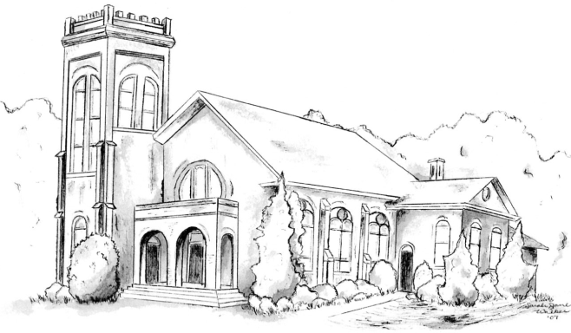

“I was glad when they said unto me,
Let us go into the house of the Lord.” – Psalm 121:1

Rev. Dr. Benjamin P. Glaser, Pastor

601-577-1359
www.bethanyarp.org
1454 Hwy 161N, Clover, SC 29710

OUR PURPOSE:

The purpose of Bethany ARP Church is to glorify God by:

Worshipping Him in Spirit and in Truth (John 4:24)
Equipping the Saints For the Work of Ministry (Eph. 4:12)
Reaching Our Community with Christ’s Gospel (I Pet. 2:9)

