Bethany Associate Reformed

Presbyterian Church

June 21, 2026

Rev. Benjamin Glaser, D.Min, Pastor

Lord’s Day Morning Worship Order of Service

Prelude
Welcome and Announcements
Call to Worship Philippians 1:9-11
*Bible Song
*Invocation and Lord’s Prayer (Debts and Debtors)
*Scripture Lesson Acts 8:9-25
Children’s Moment
*Hymn
Pastoral Prayer
Anthem
Sermon “Wisdom of the Prudent” Proverbs 14:6-8
*Bible Song
*Benediction Job 19:25-29
*Doxology
*Postlude

Thank you for joining us today for the worship of Jesus Christ,
our Common Lord and Savior. If you would like to know
more about Bethany, please fill out one of the pew
cards and place them in an offering plate.

*- Please Stand If Able

Announcements

- There is a nursery provided upstairs (0-4) as need may arise.
- Be in prayer for our VBS next week that the Lord would do a great work in the lives of the children who will join us.
- The Blessing Box is in need of donations, especially supper-making products. Please place them on the table in the fellowship hall.

- If you are not seeing emails from the Church Social app, please see Kelly Gordon. We either have the wrong email, or we do not have an email for you at all. She will help you get set up!

- Please place your offering in one of the four plates by the doors as you come in or as you go.

PRAYER REQUESTS – Eddie and Ruthann Helms, , Avery Wall, Mary Clay Crawford, High School Seniors, & Shut-Ins.

If you have any prayer requests, joys, concerns, or would like a visit, please let an Elder or Rev. Glaser know. His contact info is: 601-577-1359 and pastor.glaser@bethanyarp.org.

Nursery

June 21st:
June 28th:

FINANCIAL REPORT
June 14th : $
Needed Weekly: $ 3,669.15
Runda Mission Project: $0.00

Weekly Schedule of Classes & Studies
Sunday: Sabbath School – 10:00am
Morning Worship – 11:00am
Evening Worship – 5:30pm
Mon/Wed: Facebook Devotions and What’s That Word – 7:15am
Tues/Thurs: Prayer and Worship Help/Confessional Thursday Email
Wed. Night: Adult Study and Prayer Time/Youth Group - 6:30pm
Sermon Notes

Introduction

How Do People Who “Scoff” and Seek Wisdom Not Find It?

What is the Real Goal of Knowledge For the Christian?

Why Does Solomon Tell Us to Flee From a Foolish Man?

How is the Prudent to Act and to Think in Today’s World?

Verses for Reflection

2 Chron. 2:12, Job 11:6, Ephesians 1:7-9

2 Corinthians 10:4-5, Eccl. 2:26, Hosea 4:1

Bethany Associate Reformed

Presbyterian Church

June 21, 2026

Rev. Benjamin Glaser, D.Min, Pastor

Lord’s Day Evening Worship

Welcome

Call to Worship Psalm 139:13-24

Opening Prayer

Scripture Reading Hebrews 5

Song Selection #1 Bible Song of the Month #313

Season of Prayer

Song Selection #2 Pick a Bible Song/Hymn

Scripture Reading Romans 15:4-6

Teaching Time How to Read the Bible: Closing Thoughts

Closing Prayer

Benediction Ecclesiastes 12:13-14

Sermon Notes

- What Are the Things Written Before?

- How Do We Use the Bible to Speak With One Voice?
Welcome to Bethany ARP Church!
Founded in 1797 by Scots-Irish settlers seeking a place to worship our God according to the Scriptures, our vision is inspired by Jeremiah 6:16: “Stand in the ways and see, and ask for the old paths, where the good way is, and walk in it; then you will find rest for your souls.” Like the many old oaks in this area, we desire to grow deeply rooted in the nourishing waters of God’s Word, which flow from the ancient wells grounded in Jesus Christ.
We are a Reformed church, shaped by the biblical principles of the Protestant Reformation of the 16th century. Following in the footsteps of men like John Knox and Ralph Erskine, we hold to the Westminster Confession of Faith, which summarizes the essential teachings of Scripture.
We are also Presbyterian, meaning elders elected by the congregation govern our church. These elders work together within the broader Associate Reformed Presbyterian Church (ARP) to support our shared mission and ministry. Our motto, “In Thy Light We See Light,”, taken from Psalm 36:9 reflects our commitment to honoring Christ in preaching the gospel to all men and resting in His grace.

Join Us!
Whether you’re new to the area, exploring the Christian faith, or seeking a church home, we’d love for you to join us in worship and service. Rev. Glaser is always available.

BETHANY ARP CHURCH OFFICERS

SESSION
Jimmy McGill Ronnie Smith Adam Smith
Randy Carroll Fred Faulkner, Clerk of Session

ELDER EMERITUS
Jim Davidson

THE BOARD OF DEACONS

Class of 2026 Class of 2027 Class of 2028
Joey McGill Caleb Robinson Tim Gordon
Matthew Carroll, Chairman Hunter Robinson

Bethany
Associate Reformed
Presbyterian Church

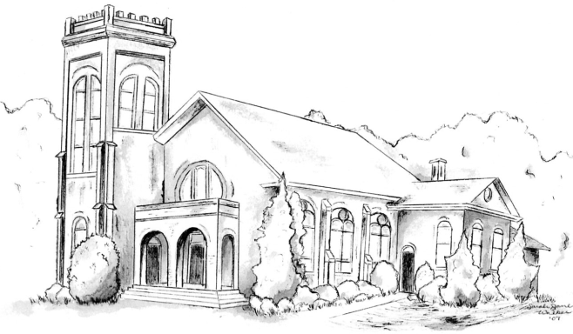

“I was glad when they said unto me,
Let us go into the house of the Lord.” – Psalm 121:1

Rev. Dr. Benjamin P. Glaser, Pastor

601-577-1359
www.bethanyarp.org
1454 Hwy 161N, Clover, SC 29710

OUR PURPOSE:

The purpose of Bethany ARP Church is to glorify God by:

Worshipping Him in Spirit and in Truth (John 4:24)
Equipping the Saints For the Work of Ministry (Eph. 4:12)
Reaching Our Community with Christ’s Gospel (I Pet. 2:9)

